**Bayes Theorem - Understand With Interactive Examples**



* **250ACTIVITIES**
* **520SPOTCOINS**

Aug 28, 2019

Bayes’ theorem gives us a very powerful tool to solve conditional probability problems. It is also an essential part of machine learning toolkits as machines use conditional probability to predict human behaviour. Will explain how this happens in a bit. But first lets try to illustrate the formula, that a lot of people find complex, with some simple examples.

**The Fair Coin Example:**

In the first example consider 2 coins one fair an one unfair. The unfair coin always resultsin a head. You don’t know which is which.

Given that the outcome of the toss is a head what is the probability that the coin is fair?

**Solution:**

We solve the problem by drawing a tree structure for the outcomes.



Now that you can visualise it the problem gets easier to solve. The solution is the number of ways the fair coin can return a head divided by total number of ways the head can occur. The answer is 1/3

**Find The Box Problem**

In problem 2, we solve a similar problem. Box 1 has 3 red and 1 green balls. Box 2 has 3 green and 1 red ball. Given that you have drawn a red ball what is the probability it is from box 2?

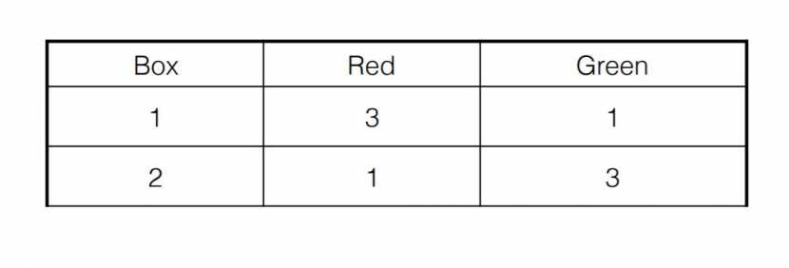

**Solution:**

The possibility that given the ball drawn is red, it came from box 2 is given by: Number of ways of getting a red ball from box 2/ Total number of ways to draw a red ball= 1/4.

***These type of problems can be solved using the Bayes theorem which helps calculate the probability given that you know other probabilities associated with the dependent conditions.***

**The Bayes'' Formula:**

**P(A given B) = P(A).P(B|A)| P(B)**

***Bayes theorem has interesting applications in machine learning. Say you have just landed in a film crazy country obsessed with Bollywood. When you hit the search engine from film-crazy country, it prompts you with Loin when you type Ajit. The smart search calculates that the probability of you typing Loin given that you have typed Ajit is high, based on the search trends in the country. Or consider how ecommerce recommendation works. How does the machine guess you will buy sneakers after picking up trackpants. It all boils down to using conditional probability to guess your behaviour.***

Finally here’s a cricketing challenge. In 90% of matches that India wins, Virat scores a half-century. India is playing a very strong Australia today and its win rate against Australia is 30%. Given that Virat has scored a half-century what is the probability India wins. Assume Kohli scores a half-century in 70% matches.



The problem can be solved using Bayes’ theorem as follows.

**Solution:**

From Bayes'theorem,

P(India wins| Virat’s half century) = [P (India wins)*P(Virat’s half-century| India wins)]/ P(Virat’s half-century)

Now, P(India wins) = 30/100 = 0.3 (Since India's win rate is 100%)

P(Virat's half-century| India wins) = 90/100 = 0.9 (Since in 90% of matches that India wins, Virat scores a half-century)

P(Virat’s half-century) = 70/100 = 0.7 ( Since Kohli scores a half-century in 70% matches.)

**P(India wins| Virat’s half century) = 0.3*0.9/.7 =27/70 or roughly 40%**

The answer is roughly 40% so India has a reasonable chance of winning the match.